Name: Abdul Ghani Khan

Section: 2A

Roll Number: 22P-9037

INSTRUCTOR: Sir Usman Wajid

OOP ASSINGMENT #1

# Introduction: -

Creation of a data base system and storing the data in arrays is what we’ve done in this assignment. A CS department with 5 sections in it and each section having max 50 students with each student having their attributes and same for the sections in having their own attributes.

TECHNIQUES USED ARE

->Structures

->Nested Structures

->Pass By Reference

->Pass By Value

->Linear Searching

->Array Handlings etc.

Then comes the admins that can control everything in this program and can change update and add anything in this database. Admins have their own attributes just like students and sections.

Note: -

This program is tested and all possible errors have been handled till the best of my knowledge. It Is made that everyone even a common man can access it made simple and highlighting every choice the user makes.

SUMMARY AS THE IDE SHOWS: -

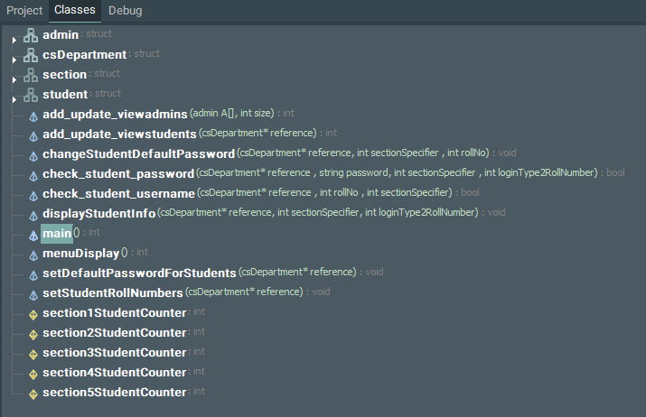

# Code: -

The Code is Given Below in the form of screen shots and in every screen shot I will try to explain what is happening.

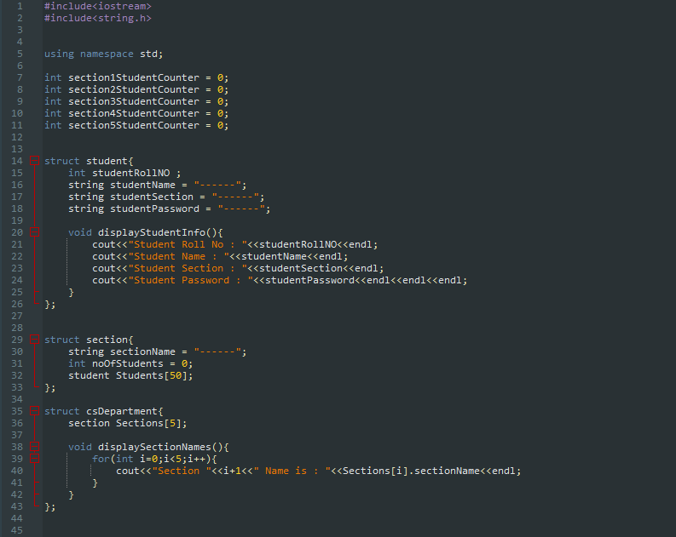

->Five Global variable seen at the top is used so that a count is maintained for each section whenever a student is added and that the data base does not override the student that was entered before and adds it on the next slot available.

->These variables by the name of section1StudentCounter as the name specifies makes the program easier in distributing the student to their respective positions in the array and always keeping the count of the students added in each section.

->Then comes the student structure as said with their own attributes and having a display function in the structure that will be needed when displaying the data of each student.

->Then comes the section structure with members as section name and number of students initialized as 0 and all the default names having default values of (-----) so they can be distinguished easily. Other then that section structure having nested structure of the student structure’s object which is an array of sized 50 that shows that each section will have 50 students each (MAX).

->Then there is CS Department structure having nested section structure’s object which is an array of sized 5 that shoes that the CS department is having 5 sections as said in the assignment that cs department will have only 5 sections. Also, with a display function in the structure that be used when displaying the section names.

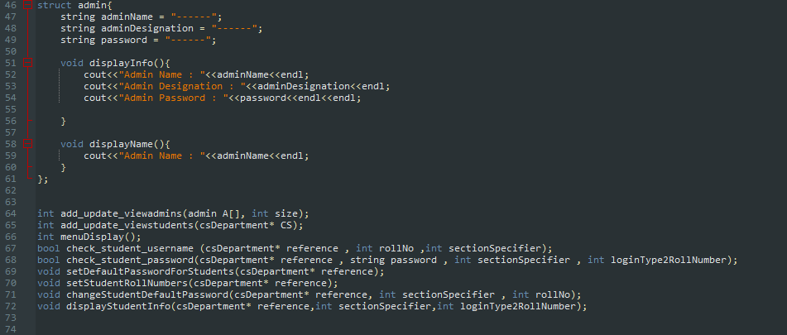

->This piece of code have an admin structure that have attributes of admin name, admin designation, and password with a display function that will help us in displaying the admin information.

NOTE: Additionally having the display name function that only displays the admin names that will be helpful for us when editing the admins as the user will see the names and update accordingly.

->Then we have a function that takes in perimeter of the array of variable admin and its size and this function is used to add, update, view the admins and their details (PASS BY VALUE IS USED).

->Then we have a function named add update views students that takes in the address of the object named CS which is an object of CS Department structure and performs the operation which is adding updating and viewing student information in the function (THIS IS CALLED PASS BY REFERENCE).

->Then We have a function of menu display that displays the main menu when the user enters the program.

->Then we have 2 functions that checks the student username and student password and returns if it matches or not. The check username function takes the roll number entered by the student and the section entered by the student and checks it and the check password function checks the password by going to the same roll number and section entered by the student and checks whether the password is right or not.

->Next function is setDefaultPasswordForStudents that sets the default password of all the students to student123 as stated in the assignment.

->Next function is setStudenRollNumber that sets the student roll number from 1 to 50 in the array.

->Next function is of changeStudentDefaultPassword that whenever a new student signs in with the default password this function is called and it changes the default password and asks the user to enter the new password as stated as a condition in the assignment.

->Next function is of display student info that displays the student info whenever a students signs in with his credentials and asks the program to display his information.

THE MAIN FUNCTION

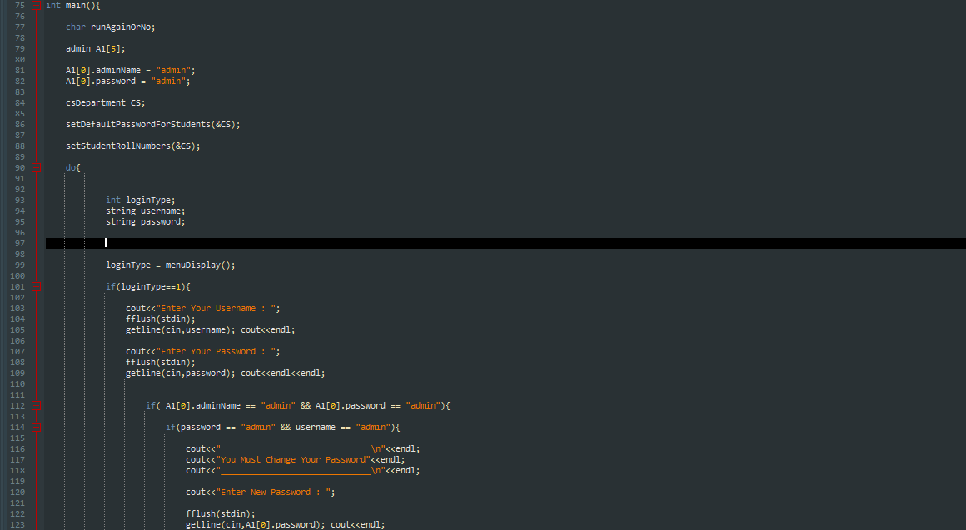

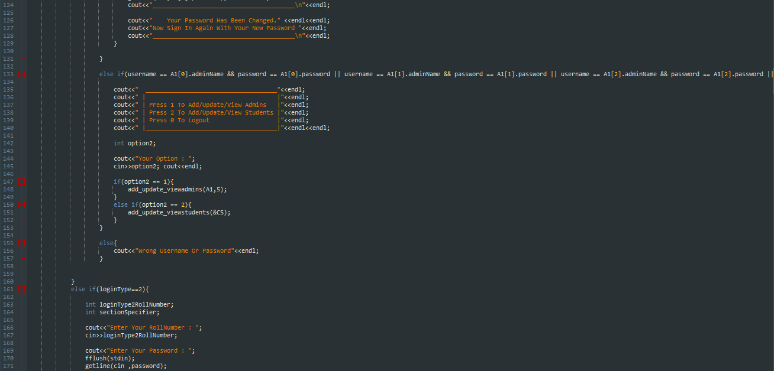

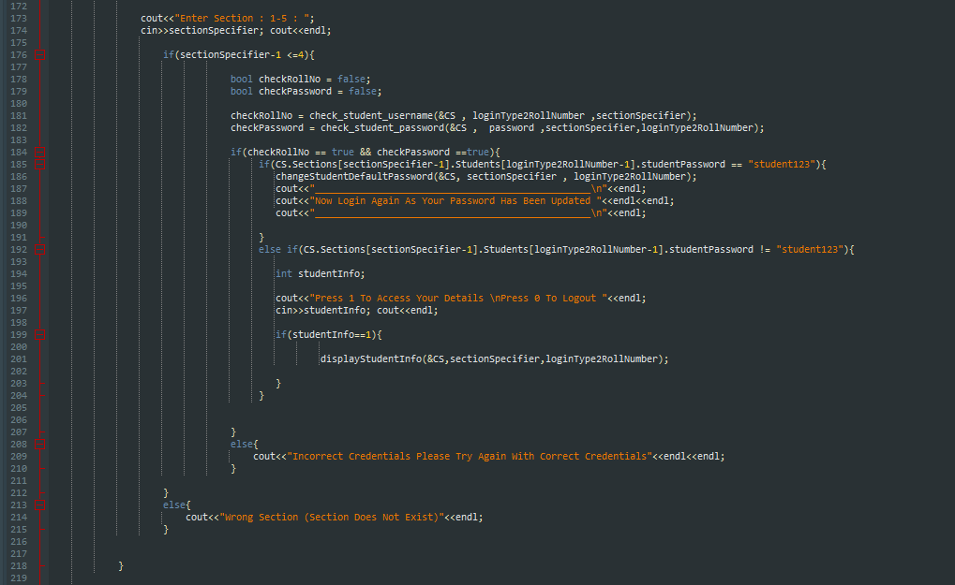

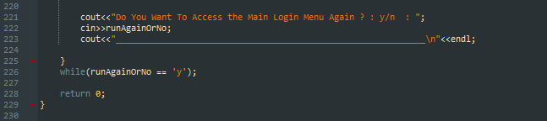

MAIN FUNCTION ENDS HERE.

DISPLAY MENU FUNCTION IS BELOW: -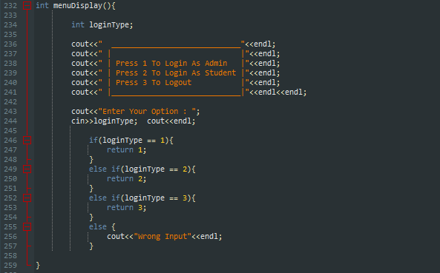

setDefaultPasswordForStudents function and setDefaultRollNumbers function is below: -

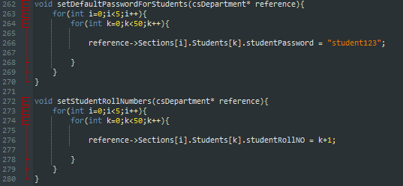

changeStudentDefaultPassword function and displayStudentInfo function is below: -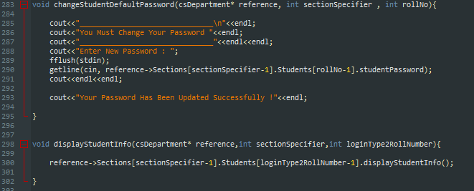

Add Update View Admins Function Is As Below: -

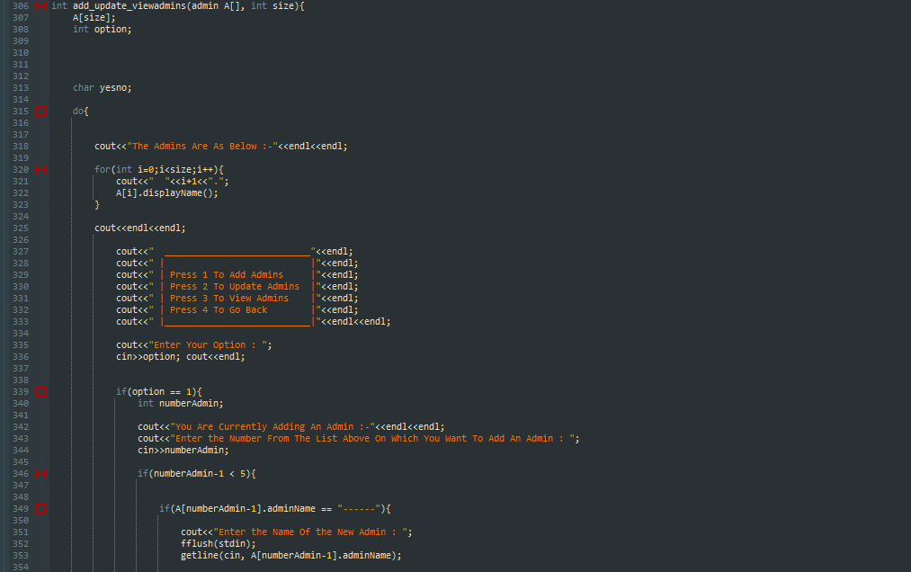

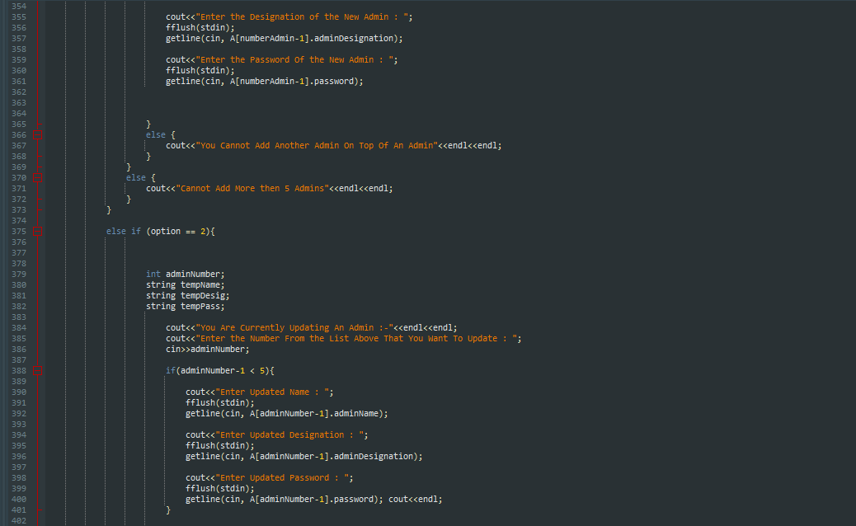

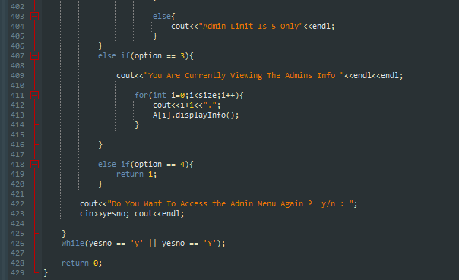

Add Update view Admins Function Ends Here. ^^

add_update_viewstudents function is as below: -

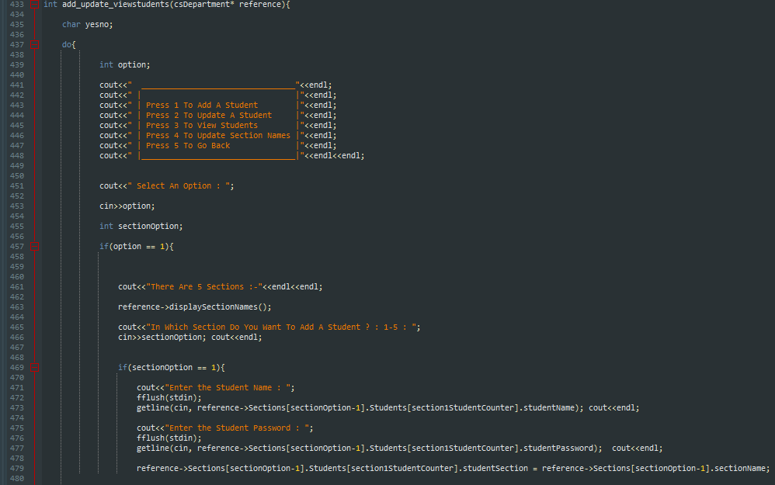

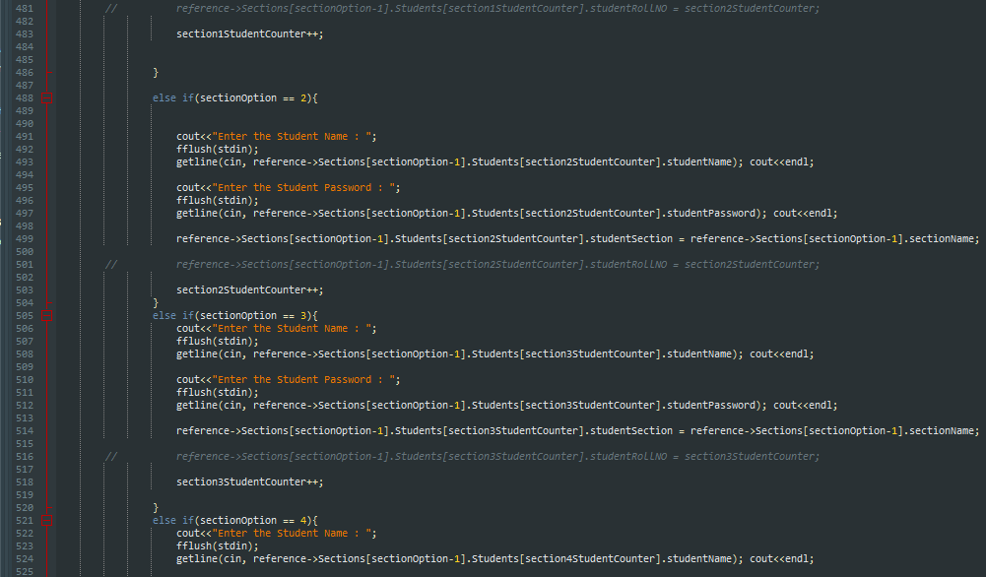

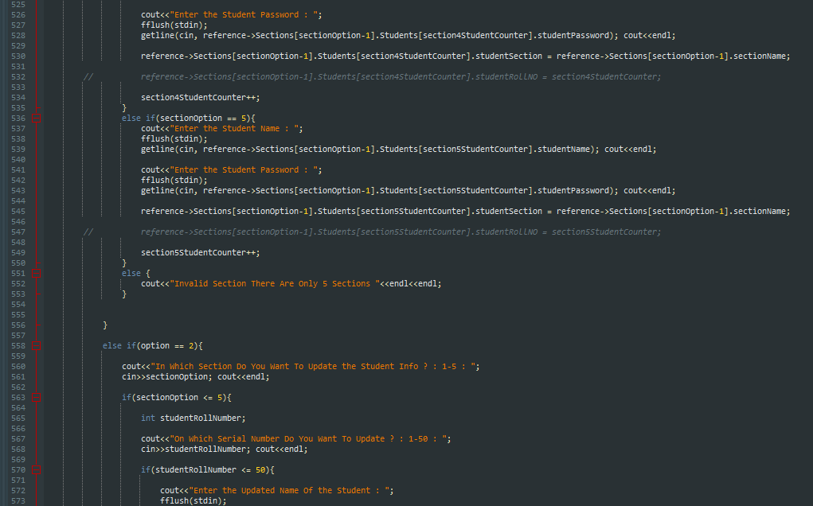

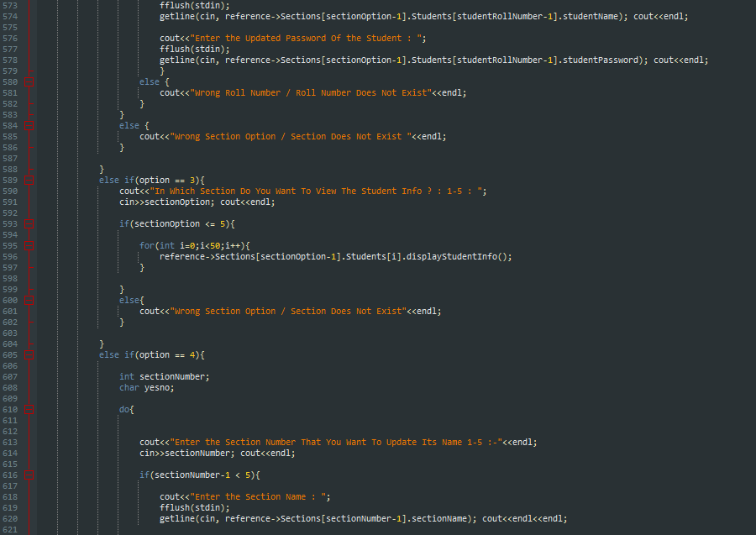

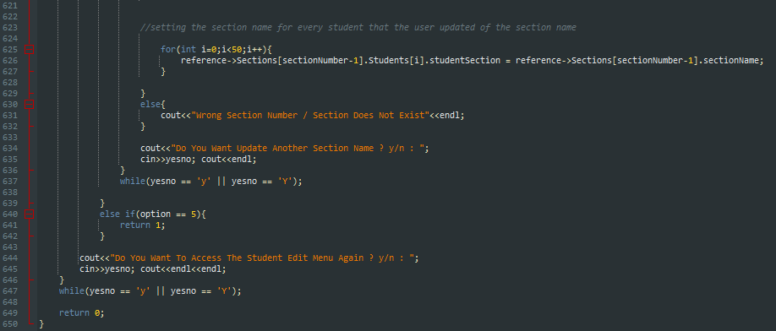

add_update_viewstudents function ends here. ^^

check_student_username function and check_student_password function is as below: -

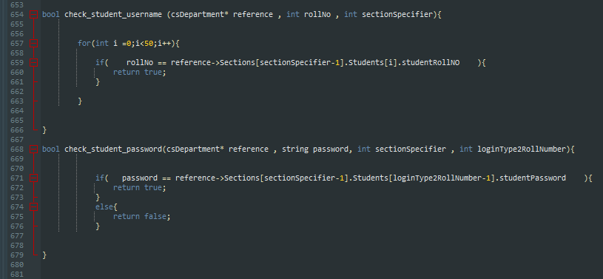

# AND THAT IS GONNA BE THE END OF THE CODE SECTION.

# OUTPUT: -

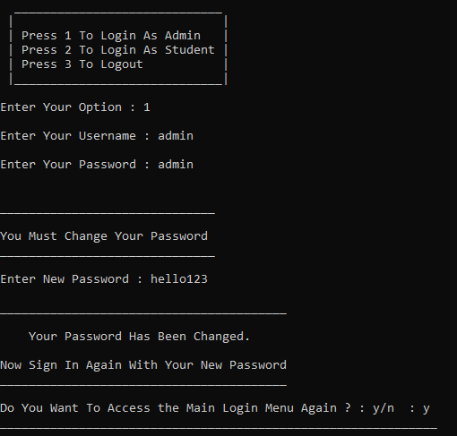

As it accepts the default password and username which is admin and admin it says to change and after it changes it it tells me to sign in again.

Then I Press y to access the menu again and sign in again with my new password which I kept as hello123.

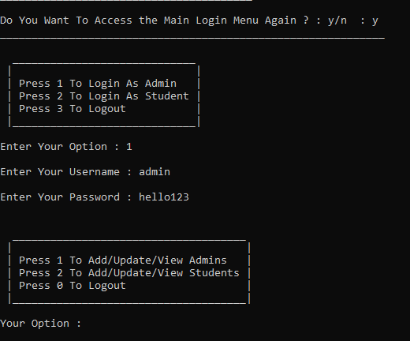

After entering my updated credentials, it gives me an option to edit admins, edit students or logout.

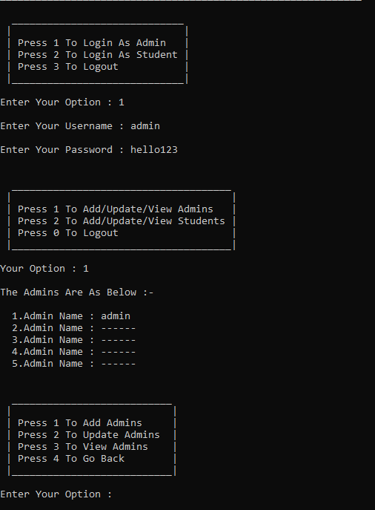

When I press 1 it goes in the tab to updating admins and shows me the current admins in the list just for the easiness of the user.

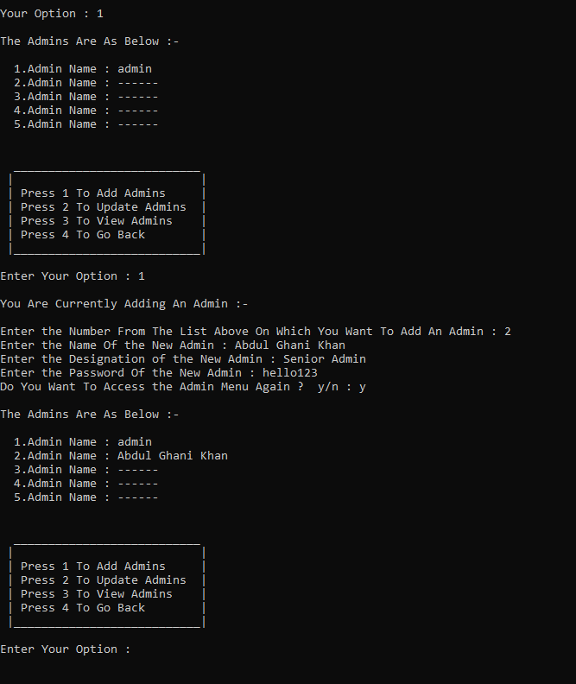

I pressed 1 and added myself on the 2nd number of the list as an admin by the name of Abdul Ghani Khan and kep my password and designation as above.

Then pressed y to access the admin menu again and see it shows me as the second admin

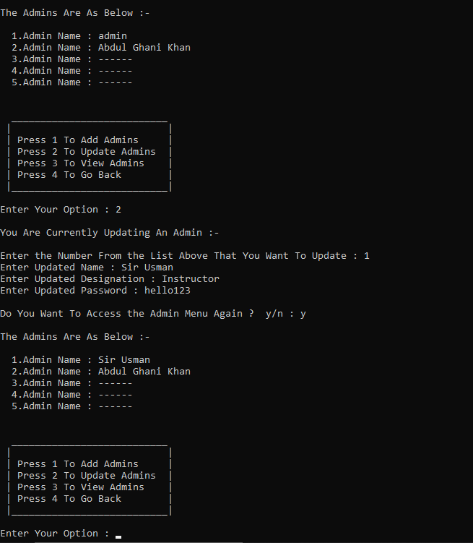

Now this time I pressed 2 to update the admins and I updated the first admin as Sir Usman Wajid and updated the designation and password and then accessed the menu again.

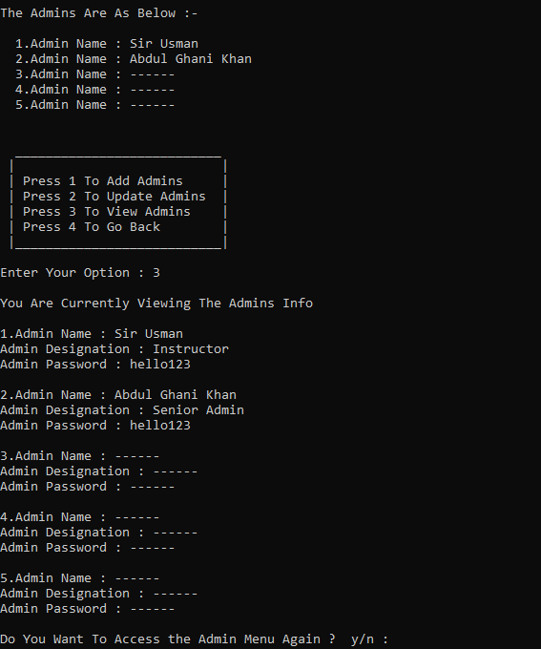

Now as I pressed 3 this time it shows me all the info of the current admins and as seen it works like a charm.

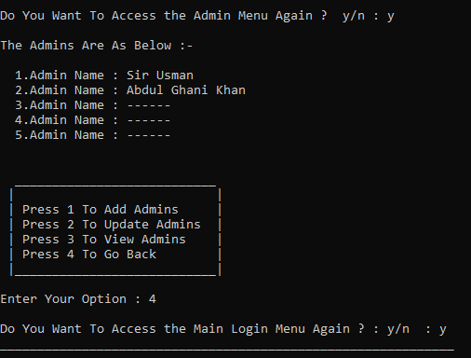

This time I pressed 4 to go out of the menu and selected y to access the main login menu again

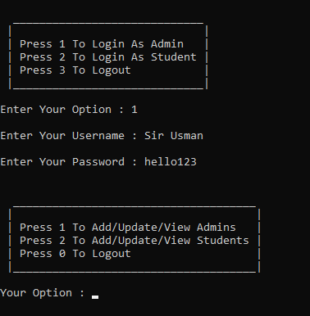

And this time I used the new credentials that we updated earlier and it lets me in.

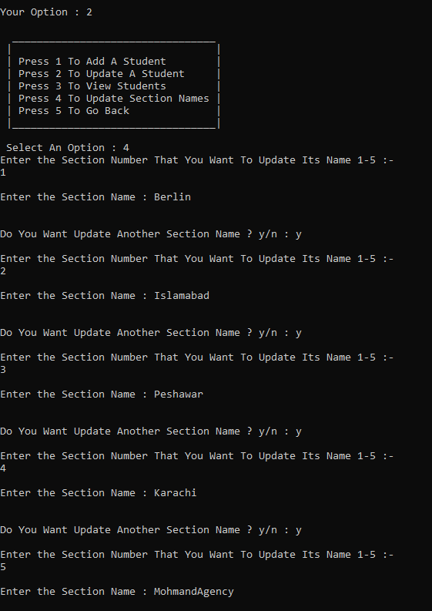

This time I pressed 2 to edit student info and updated all the sections name as above.

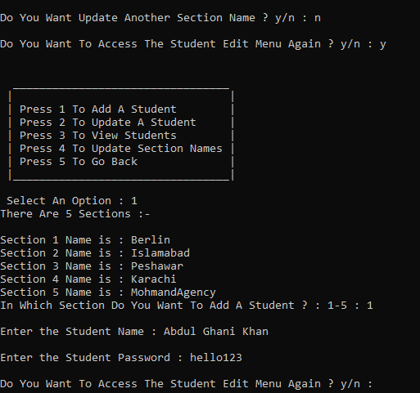

Now Im accessing the student edit menu again and adding a student in section 1 which is berlin by the name of Abdul Ghani Khan and setting his password by hello123.

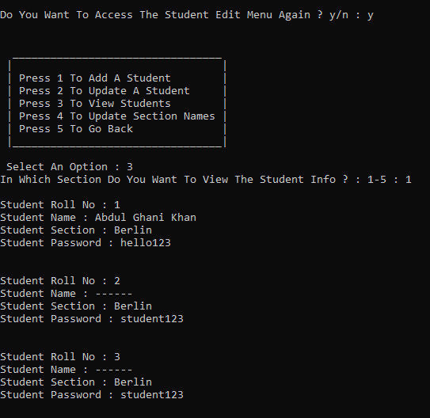

As now I have accessed the menu again and pressed 3 to access the view students and then selected for section 1 which is Berlin

The student List for all the students in that section is opened which is from 1 to 50 and as we can see we had added a student named Abdul Ghani Khan before it shows it on the first slot with their full info and the rest are empty with their default password as said in the instructions.

So Now We Have Abdul Ghani Khan On Roll Number 1 Of section 1 Which is Berlin.

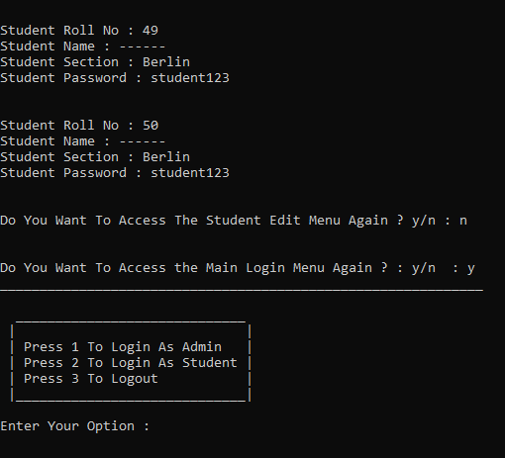

I made my way back to the main menu .

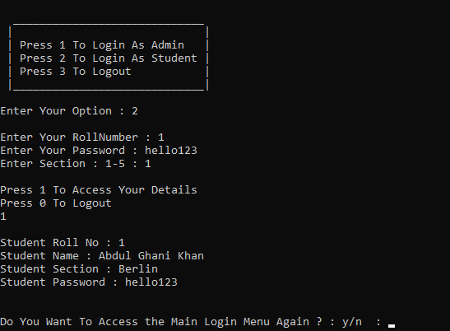

I selected 2 from the main menu and entered the credentials of the student that we added earlier when we accessed the admin menu.

Then pressed 1 to access the student details and see it shows the info of the student that signed in.

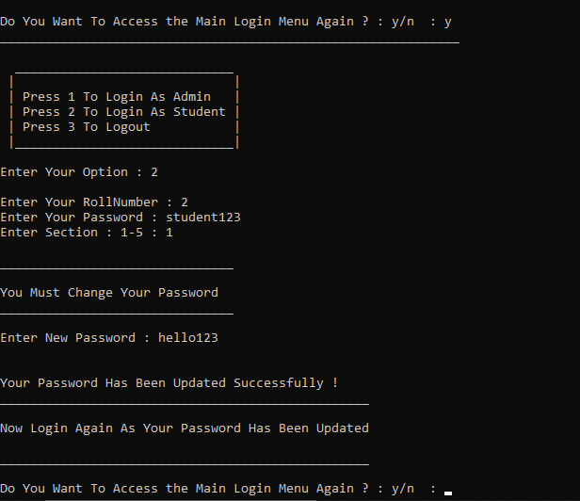

Now I accessed the main menu again and pressed 2 to login as a student and this time I signed in as a default student as in section 1 there is no student on roll number 2 so as the assignment said to make the default password as student123 so I entered roll number 2 and default password as student123

After which it tells me to change the password so I changed it and wrote hello123.

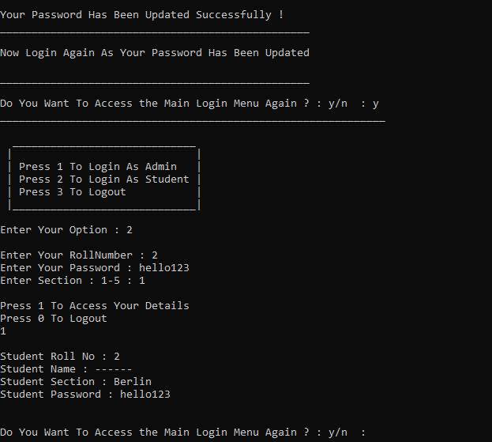

Now I accessed the menu again and accessed roll number 2 of section 1 with the new credentials and see it lets me in.

It Doesn’t shows the name as we haven’t updated his name and AS THE ASSIGNMENT SAID THAT STUDENT CAN ONLY VIEW HIS DETAILS.

So now im gonna update the student roll number 2 and then come back sign in with the updated details.

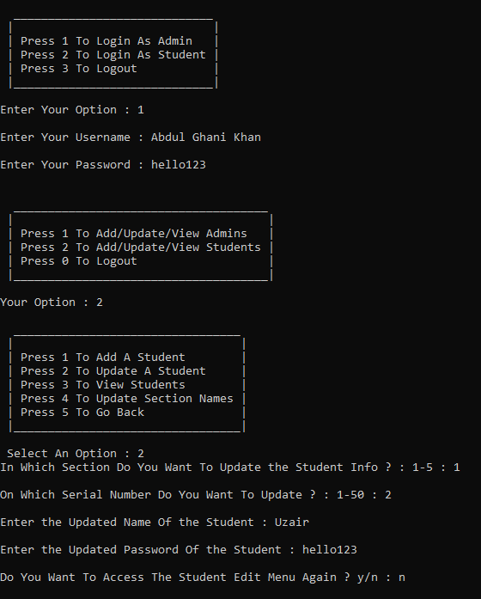

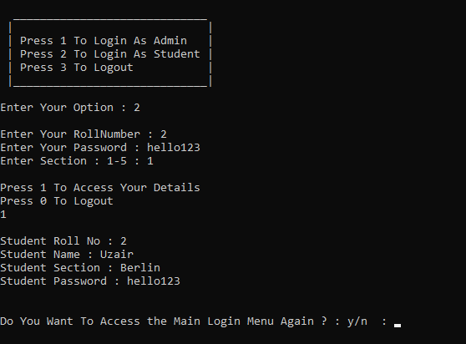

Now after updating his name through the admin we can see his details now.

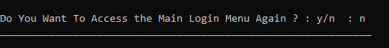

The program exits after entering n when it asked do you want to access the main login menu again.

# THE END. THANK YOU